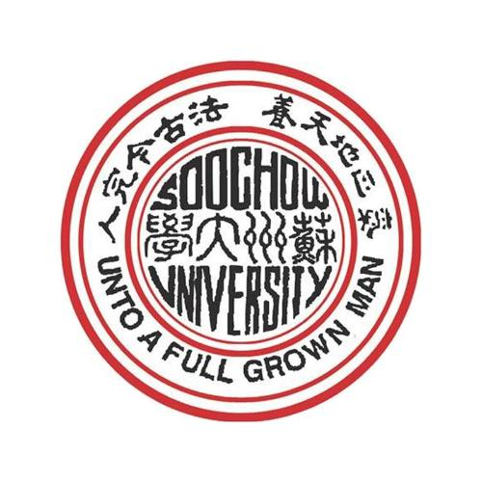
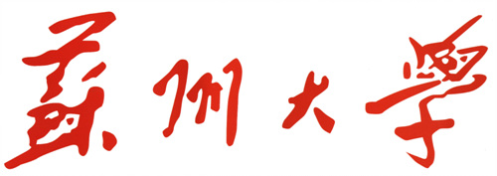


证明
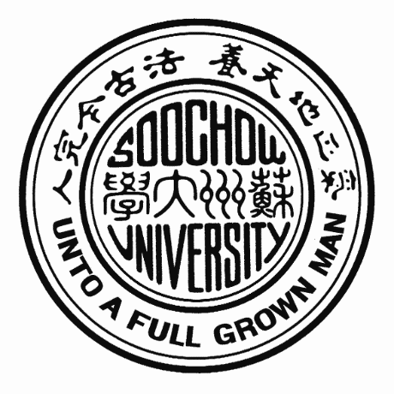
学生XXX，性别X，学号XXX，20XX年9月进入我校能源学院新能源材料与器件（中外合作办学）专业学习，学制五年。现为在校四年级学生。该生若未赴加拿大维多利亚大学参加中外合作项目，可在我校继续学业。该生若能在20XX年6月通过学校的毕业资格审核和学位资格审核，届时即可毕业并获得学士学位。
苏 州 大 学
20XX年XX月XX

certificate
This is to certify that XXX, male/female, registration No. XXX, is a senior student, who was admitted to Soochow University for a five-year undergraduate program in College of Energy, majoring in New Energy Materials and Devices (Sino-foreign Cooperative Education) in September 20XX. She/He may continue to study at Soochow University if she/he does not participate in the exchange program at the University of Victoria. She/He will graduate and be awarded a Bachelor's degree if she/he meets the graduation and degree requirements in June 20XX.
Soochow University
Date: XXX, 20XX

